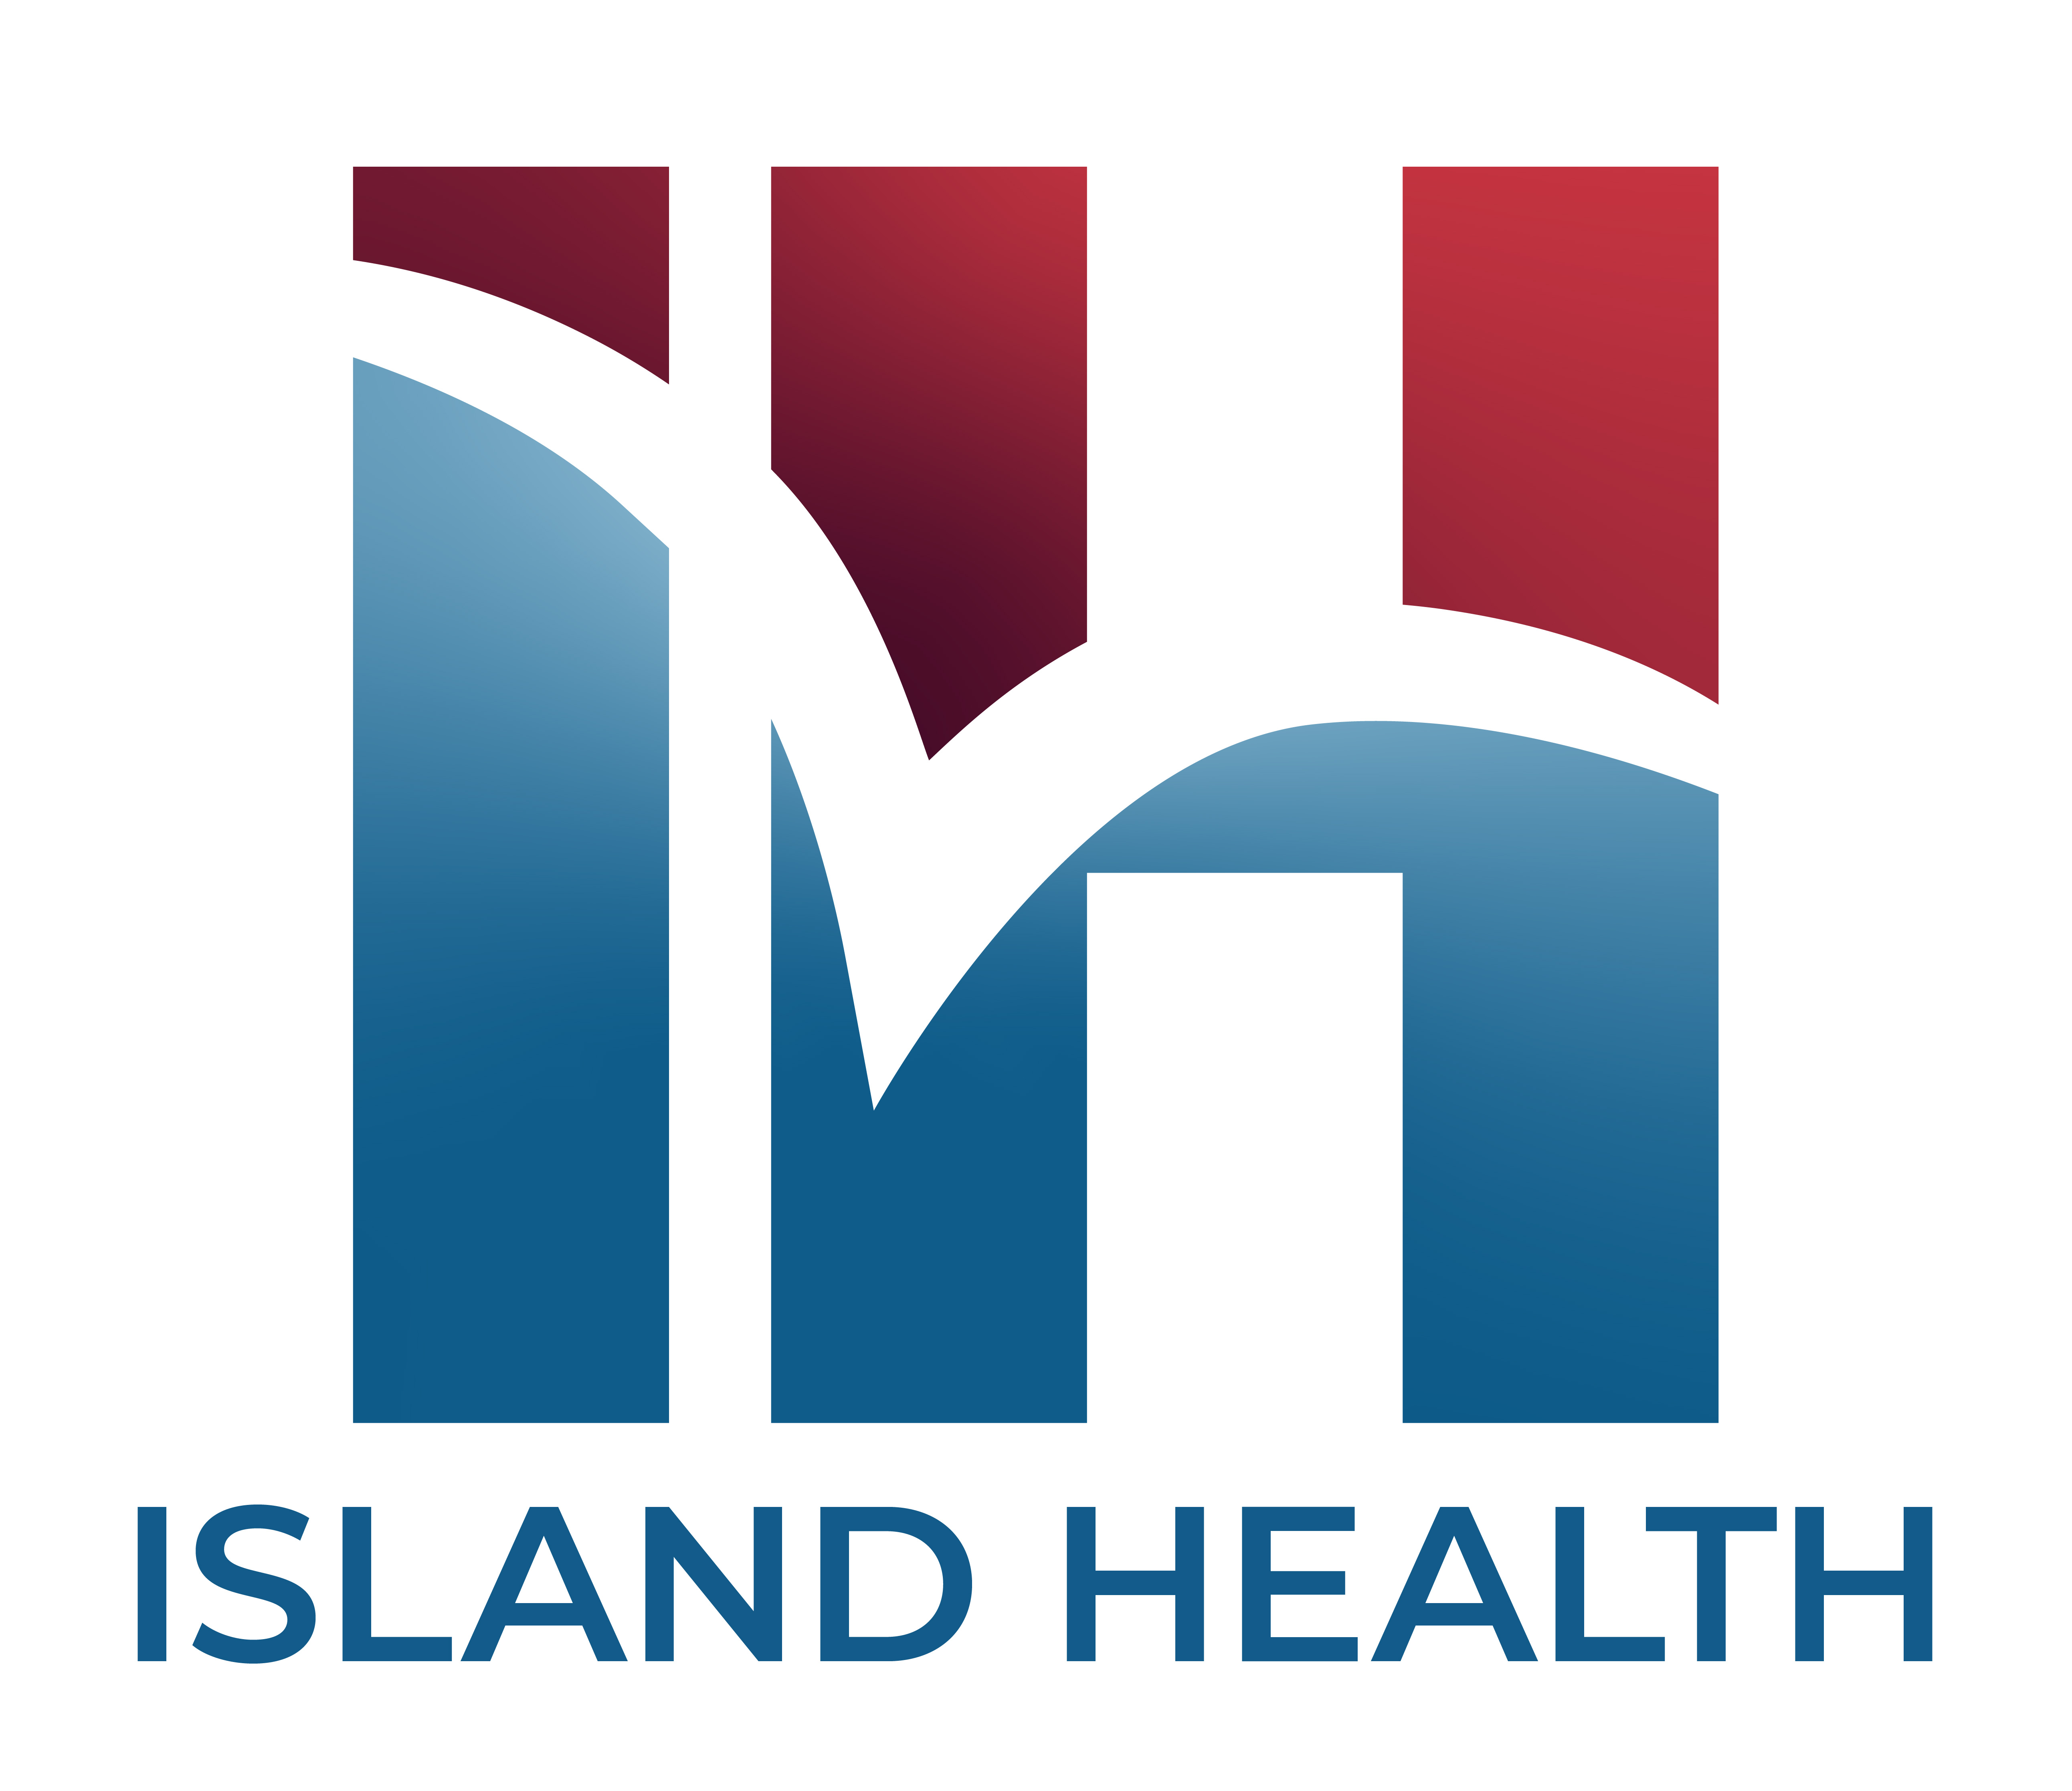

September 28, 2022
Regular Board Meeting
Cypress Room & Via WebEx (408) 418-9388 code: 2495 304 5576
12:00 PM
Call to Order J. Iversen President/Commissioner
- Public Comment, If any

Note: If a member of the community wishes to speak during the open part of the meeting, he/she must present to the CEO/President, before the Call to Order, the topic which will be presented. Presentation is limited to 2 minutes.

- Action Items Completed
- Charity Care Report
- Paramedic Patient Metrics

- Consent Agenda-ACTION J. Iversen President/Commissioner

- Minutes Working Board Meeting-August 10, 2022
- Minutes Regular Board Meeting-August 24, 2022
- Board Warrant
- Resolution No. 2022-2141 Surplus Capital Equipment

- Board Quality & Patient Safety C. Bogosian, MD Commissioner
L. Lang, PhD Commissioner
- Medical Staff Report R. Carter, DO
- Quality Report A. McCoy

Page One of Two

- Finance P. Maughan, PhD, Commissioner
W. Tessler, Commissioner
a. Monthly Financial Performance August 2022 J. Stewart, CFO

- Administration Update
b. Provider Recruitment J. Hogge, CMO
c. Patient Experience V. White MSN, Interim CCO
a. Administration Update E. Cutter, CEO

- New Business
a. Island Hospital Foundation J. Crane
b. Strategy Committee J. Iverson/L. Lang
1. Resolution No. 2022-2142
Amended 2022 Hospital Bylaws ACTION
2. Adoption of Commissioner Code of Ethics Policy ACTION
c. October Board Calendar E. Cutter, CEO

- Executive Session-if necessary J. Iversen President/Commissioner

- Adjournment J. Iversen President/Commissioner

Page Two of Two



September 28, 2022
Regular Board Meeting
Table of Contents

- Public Comments/Agenda/Action Items

- Consent Agenda

- Medical Staff Update

- Finance Update

- New Business/Reading Materials

- Adjournment

